Dundela Infants’ School and Nursery Unit



Nursery Parent Information Booklet

September 2023

Dundela Infants’ School and Nursery Unit



Welcome to Dundela Nursery School

Wilgar Street,

Belfast,

BT4 3BL

Tel: (028) 90471234

Principal: Ms S Wilson B.Ed. (Hons.) PQH (NI)

Email: [info@dundela.belfast.ni.sch.uk](mailto:info@dundela.belfast.ni.sch.uk)

Dundela Infants' School Nursery Unit is an integral part of Dundela Infants' School. The nursery has two full day classes of 26, each staffed by a teacher and a nursery assistant. The nursery day begins at 8.45 am until 1.30 pm and school dinners are provided. The children have access to a wide range of resources both inside and outside and we have dedicated and experienced staff who work alongside the children. Our aim is to facilitate and develop their learning in the play activities that they choose.

We strive to provide a welcoming and inclusive environment, so that all children reach their potential by:

•Promoting a positive behaviour and discipline policy

•Promoting a caring ethos where there is mutual respect between staff and children

•Ensuring an engaging environment with lots to investigate and explore

•Encouraging a wide and varied range of visitors to nursery, to extend the curriculum

•Ensuring the environment is safe and secure

•Encouraging parents to work with staff as partners in their child’s education

•Keeping parents informed of what happens in nursery, through monthly newsletters, school website updates and class updates via the see-saw app

**The Curriculum**

We follow the Northern Ireland Pre-School Curriculum Guidance which aims to ensure that each child develops at their own rate through challenging progressive play. There will be a wide variety of well-planned and spontaneous experiences so that children will be engaged in learning situations designed to foster a range of skills.

The Pre-School curriculum is broad, balanced and provides progression. The holistic development of the child is kept at the heart of the curriculum with stimulating and child appropriate activities. Skilled early years practitioners also follow the lead from the child in their learning by taking an interest in what they are playing with and helping to develop their play through effective questioning and playful interactions.

The curriculum consists of six areas of learning:

1. Personal, Social and Emotional Development

2. Language Development

3. Early Mathematical Experiences

4.The Arts

5. Physical Development and Movement

6. The World Around Us

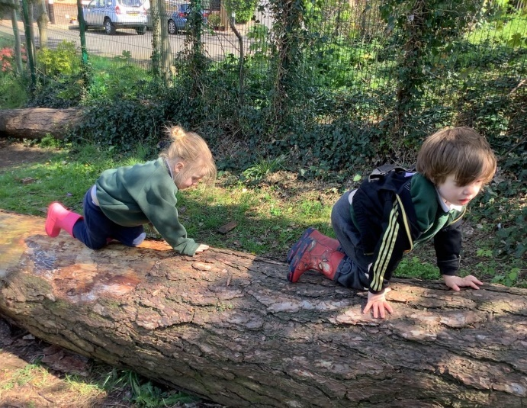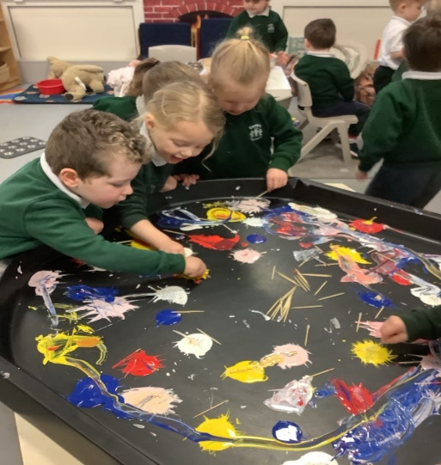

Please use the following link if you would like to learn more about the Pre-School Curriculum:

<http://ccea.org.uk/curriculum/pre_school>

**Staff**

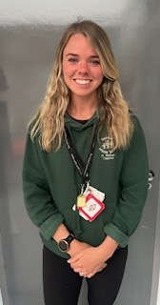

Miss R McKee Miss M Wilson

Nursery 1 Teacher Nursery 2 Teacher

Head of Nursery

Deputy Designated Teacher for Child Protection

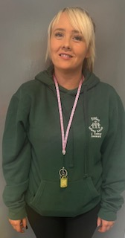

Miss J Connor Mrs M Morris Mrs V Quinn

Nursery 1 Teaching Assistants (Job Share) Nursery 2 Assistant

**Help your Child Prepare for Nursery**

Here are some suggestions to help prepare your child before coming to nursery:

* Talk to your child about going to nursery and how exciting it will be. Talk about the nursery staff and the different areas of the nursery, i.e. inside play areas, quiet room, toilet area, outdoor area etc.
* Allow your child to have opportunities for messy play, i.e. water, sand, dough and paint;
* Read lots of stories and sing nursery rhymes with your child;
* Create opportunities for your child to mix with other children and adults;
* Go over our Golden Rules with your child (page 17);
* Encourage your child to help at home and to become independent in certain tasks, e.g. using the toilet independently, eating independently and tidying up toys independently;
* Fill in your ‘Special Me’ book with your child

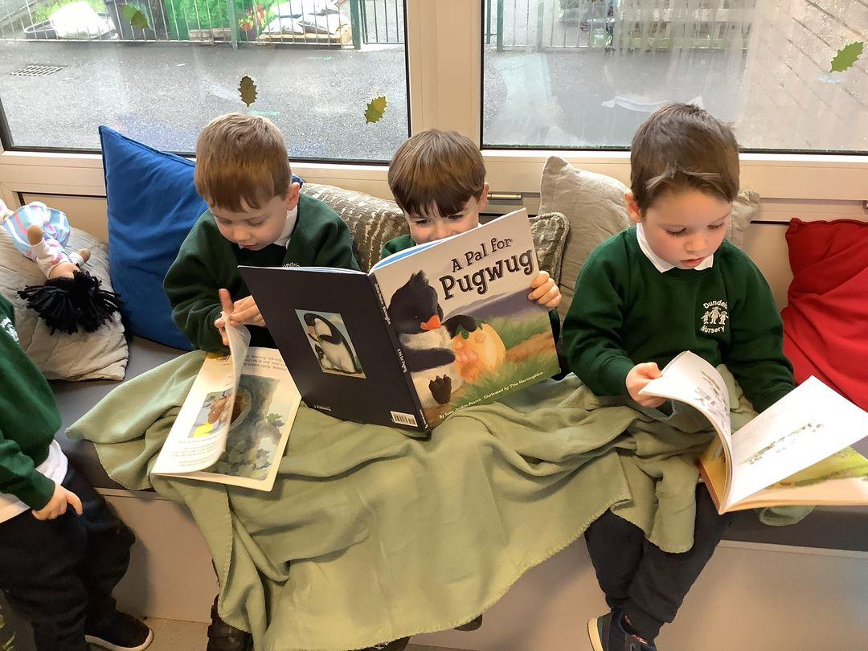

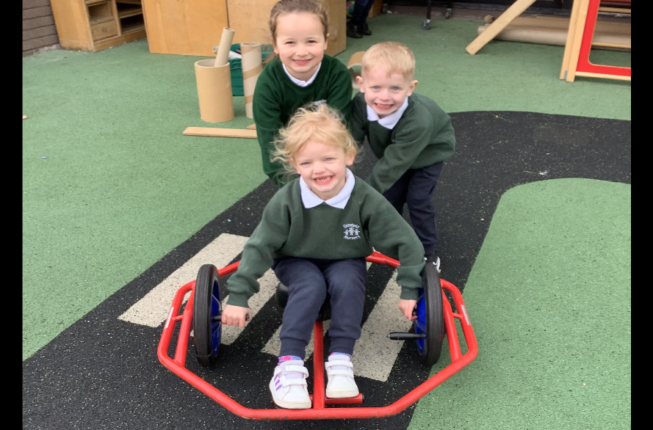

We regard you, our parents, as partners and your interest, support and co-operation are very important to life in the nursery, particularly as you have been your child’s first and foremost educator. We hope you will support your child, realising the benefits of early years’ education and extend the school experiences at home.

**Settling in Stages**

This is a very new experience for your child and for you. We aim to work along with you to ensure that your year at nursery will be a positive and happy experience. **We will treat each child as an individual and the pace at which they settle, will be determined by their particular needs.**

Stage 1

A short home visit will be arranged in **June** or **August** for you and your child to meet your nursery teacher and assistant.

Stage 2

Starting nursery- Children will attend in small groups of 13 for one hour. (Children with a statement of educational needs will be brought in prior to this.)

* This benefits your child as during the settling in period we aim to get to know the children very well and help them quickly get used to the rules and routines of nursery. This will work best when there is only a small number of children present.
* The children will be able to form friendships and gain confidence in themselves and their surroundings in a quieter setting.

Stage 3

As the weeks progress, the time your child spends in the nursery will be increased until your child is staying for the full session.

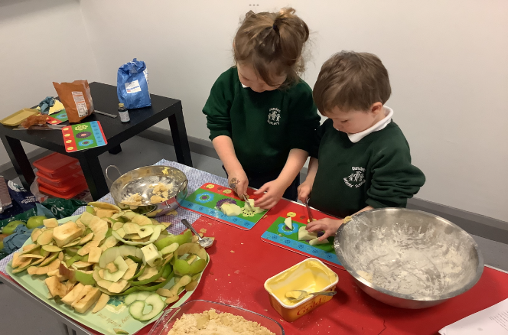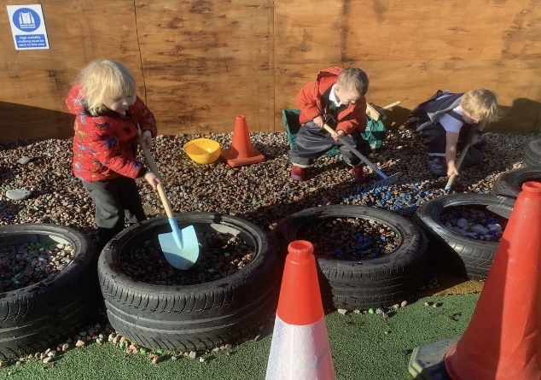As your child becomes familiar with the new surroundings and gets to know the other children and the staff, they will become more confident and happier. The staff will observe your child closely and if we feel they are having any difficulty settling we will discuss this with you and a staggered settling in period will be agreed. Also, if you feel your child is having difficulty settling in then please let us know.

**Arrival and Collection Arrangements**

Arrival

The nursery operates from 8.45am – 1.30pm each day. We regard the first 10 minutes of each session as a flexible arrival time to allow for primary school drop offs. The doors to the nursery will be locked 10 minutes after the session has started. If you are late, go the main reception door. Please do try to arrive within the flexible time.

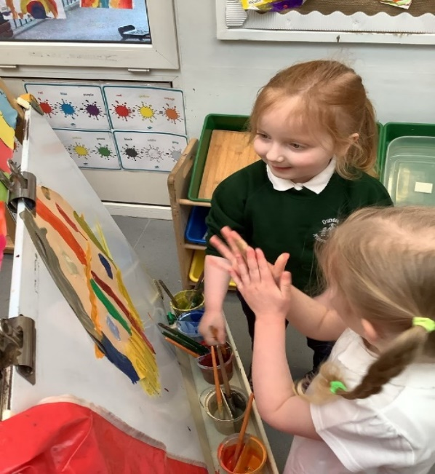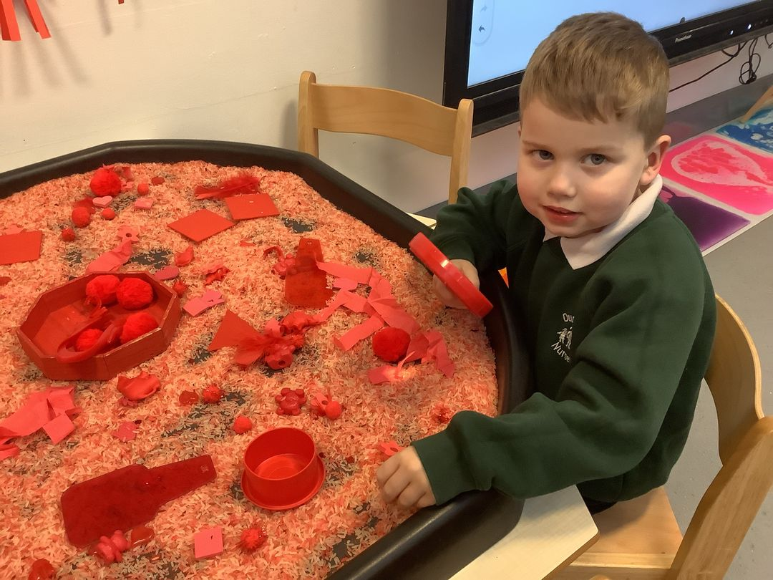When you and your child arrive, please help them to hang up their coat. As the year progresses, we will be encouraging all children to become more independent and do this themselves. Please make sure your child is safely in the classroom and do not leave your child in the cloakroom in the mornings. Please remind your child to find their picture to sign in at the registration station before you leave. Ensure your child is safely handed over to the care of the teacher and that the teacher has acknowledged their arrival.

Leaving your child into nursery can be a very emotional time for both the adult and child. We fully understand this and we will do everything we can to facilitate a smooth transition from home to nursery each day. Please take the advice of the nursery team - we do have lots of experience!

Collection

The safety of your child is of paramount importance to us. Therefore, the following procedures have been put in place: -

•You must complete the collection form giving the names of the 2 or 3 people most likely to be collecting your child during the year and state their relationship to the child. Names can be added throughout the year if needed.

•Unfortunately, we are not able to send a child home with anyone other than those named. The named persons must be over 16 years of age. (We also cannot release children to siblings who are under 16 years of age.)

•If there is a problem with the collection of your child you must phone the school as soon as possible.

•It is very distressing for young children when parents arrive late. However, we do realise that on rare occasions this cannot be helped. If your child is going to be picked up late, please phone the school as soon as possible so we can prepare and reassure your child.

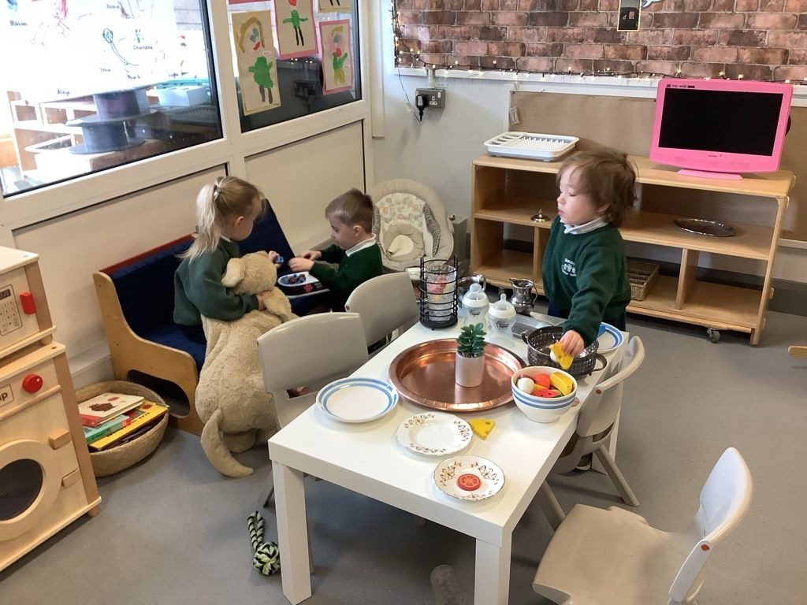The nursery has a very busy day and for the last 10 minutes children will usually be engaged in quiet activities in their room. There is a flexible collection time from 1.20pm – 1.30pm each day. Parents are invited to come into the classroom to collect their child, and are welcome to complete a short task with them, see their art work or play.

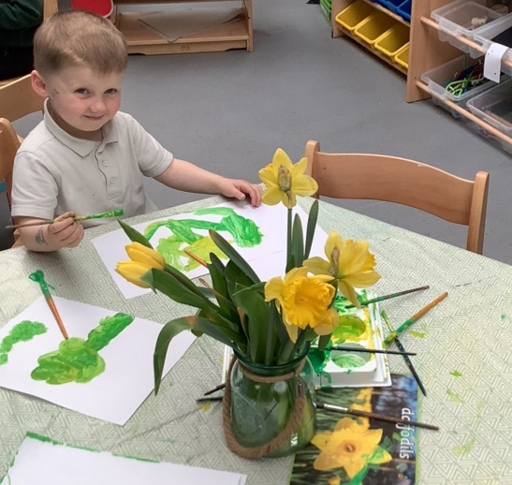  
Cars should be parked outside the school gates. The car park is for staff only. PLEASE DO NOT ENTER THE CAR PARK TO TURN YOUR CAR WHEN THE GATES ARE OPEN.

**The First Day**

Please ensure that you have the following ready to bring on your child’s first day at nursery:

1. A clearly labelled bag with a change of clothes (all labelled) for your child.

2. A box of tissues and two packets of baby wipes.

3. A pair of labelled wellington boots.

4. A small book has been provided for you to stick in photographs of people, places and events which are special to your child and we would ask that this is returned to nursery on your child’s first day. Your child can then use this ‘Special Me’ book as a source of comfort throughout the year as they look at the photographs of familiar people and places. Feel free to write captions underneath the photos as this will be a great help to the nursery team when discussing the book with your child.

Please ensure all consent forms and contact information sheets have been returned before your child starts. Staff will ask for these during the home visits in June or August.

We will use the Seesaw app to communicate with you, to send newsletters and to share photos.

A typical day

Every day in nursery is busy and packed with lots of fun filled things to do. Here is one example:

* 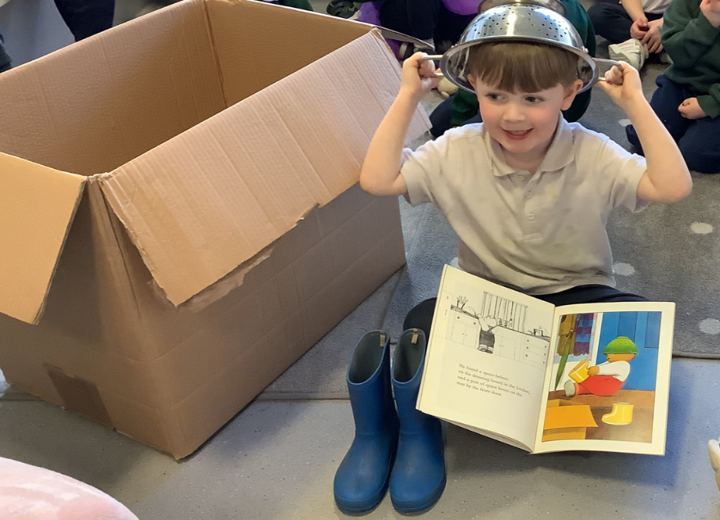Arrival and self-registration
* Play based learning
* Snack
* Outdoor play
* Quiet room time: story, songs, circle time
* Lunch
* Outdoor play/ Forest School
* Small group time/ table top play
* Home time

**Online Payment System**

We are delighted to inform you that we now use the online payment system **SchoolMoney.** This means that you will now have the facility to make payments for nursery expenses online with your debit or credit card.

It will not be necessary for you to sign up to this system as this is done automatically when your child is admitted on the school system. At this stage you will be sent a welcome message and a password to log on.

This new payment system will benefit both us as a school and you as a parent. Not only will you be able to pay for items from the comfort of your own home but you will also be able to access your account at any time to see if there is anything you need to pay for.

If you have a child at Strandtown, you will already be familiar with the system.





**Nursery Fund**

This money is payable for the whole term at the beginning of each term. Nursery Fund pays for snack, educational visits to nursery, seasonal activities and some additional resources. Money should be paid online. Payment may be made on a monthly basis if this is more suitable.

For 2023 / 2024 Nursery Fund is as follows:

**Term 1 £60; Term 2 £45; Term 3 £45 (£15 per month = 75p per day).**

**School Dinners**

**Currently £12.50 per week (£2.50 per day.)** *We will advise if there are any changes made by the EA.* It is important that dinner money is paid online by Sunday midnight, for the following week. If you think your child may be entitled to free school meals a form is available from the School Secretary. Children are unable to be placed on the free meals register until written confirmation has been received from the Education Authority. It is essential that these forms are returned to the Education Authority prior to your child starting nursery.

**Uniform**

Children in nursery wear a uniform that is comfortable and practical. Uniform consists of the following:

Bottle green sweatshirt with school logo

Navy blue jogging bottoms

White polo shirt

Sweatshirts and jogging bottoms are available from The Signature Works on the Castlereagh Road or from their website at [www.signatureschools.co.uk](http://www.signatureschools.co.uk). They will also be available from the end of May at [www.uniformstore.ni](http://www.uniformstore.ni). We ask that you name all items of clothing and that comfortable shoes should be worn. Shoes with **velcro** should be worn to nursery as we will be encouraging children to change their shoes independently. Young children are often unable to independently manage laced shoes.

**Additional Information**

Medical details

It is important that parents keep the class teacher informed of any medical details relating to their child. This includes the use of inhalers, allergies, dietary needs, speech therapy, occupational therapy, wearing of glasses, along with details of any other illnesses about which it is important we have information.

School staff are not permitted to administer medicines. If your child has a specific problem which may require medication in school, you are asked to discuss the matter with the class teacher. Children who are unwell should not be sent to nursery and should be kept at home until 48 hours have passed from the end of their illness. Asthma information sheets will be provided for children who require medication during the school day.

Birthdays

We welcome a birthday cake on your child’s birthday as these are special occasions to share with our friends in nursery.

Please ensure it is a nut free cake and check with your child’s teacher about any other allergies the children in the class may have.

Personal details

If you move to a new house or change your phone number during the year, it is very important that you send us your updated information. We may need to contact you if there is a problem concerning your child.

Progress meetings

Parent teacher meetings will be held in October and March each year. You will be invited for a ten minute appointment to discuss how your child has settled into nursery and the progress that they are making will be shared. End of year reports are sent out at the end of June and sent on to your child’s P1 teacher. If you wish to speak to your child’s class teacher at any other time, please make an appointment to do so after school.

**Child Protection**

We have a responsibility towards the children in our care and each child has a fundamental right to be protected from harm. Dundela Nursery School fully recognises its responsibilities for child protection. You will receive a copy of the Child Protection and Intimate Care Policy before your child starts nursery.

I have a concern about a / my child’s safety.

I can talk to the class teacher.



If I am still concerned, I can talk to: -

* Ms S Wilson, Designated Teacher for Child Protection or
* Mrs J Herron, Deputy Designated Teacher for Child Protection or
* Miss M Wilson, Deputy Designated Teacher for Child Protection (Nursery)



If I am still concerned, I can talk/write to the Chairperson of the Board of Governors, Mr W Pinkerton





At any time, I can talk to the Duty Social Worker at: - Gateway, Children’s Social Work Service on 02890507000 or PSNI Central Referral Unit on 101 **email: cru@psni.police.uk**

If you have escalated your concern as set out in the above flowchart, and are of the view that it has not been addressed satisfactorily, you may revert to the school’s complaints policy. This policy should culminate in the option for you to contact the NI Public Services Ombudsman (NIPSO) who has the legislative power to investigate your complaint

Parents may have access to the schools full safeguarding policy which is available on the website and from the office.

Complaints Procedure – At a glance

**Stage One**

Write to the Principal Ms S Wilson

**Stage Two** Write to the Chairperson of Board of Governors Mr W Pinkerton C/o Dundela Infants’ School and Nursery Unit

If unsatisfied, parents can also contact the NI Public Services Ombudsman Tel: 0800 343 424 Ombudsman Progressive House 33 Wellington Place, Belfast BT1 6HN

Parents may have access to the school’s full complaints policy which is available on the website and from the office.

**Intimate Care**

**Toileting Policy**

* It is presumed that all children will be toilet trained before coming to nursery.
* As a school we will endeavour to support parents with toileting by encouraging children to use the toilets regularly and with increasing independence.
* A child who is asking for help in the toilet should be encouraged and directed how to clean themselves where possible and children will be encouraged to take responsibility for their own dressing and undressing.
* Whilst children in the nursery may be at differing developmental stages regarding toileting or managing clothing, staff will always offer an appropriate amount of assistance with changing.

***Please note-Staff do not routinely provide assistance such as wiping bottoms.***

* If a child has a toileting accident the nursery Child Protection Policy Guidelines will be followed.
* We respect and value the voice of child, therefore if they refuse to change or do not want us to help, we will stop and contact you immediately

**What we will do if a child become distressed during the changing process**

* Talk the child through each step and reassure them that they will feel much better when they are clean.
* If the distress is such that it is difficult to continue then stop the changing process.
* If this results in a hygiene issue, then parents should be contacted to explain the situation and an agreed course of action established.
* In any event a record must be made of distress, whether or not the changing was completed, and parents informed as soon as possible.
* If there is any concern regarding child protection issues, these should be dealt with in accordance with school policy.
* If toileting accidents become a regular occurrence, the staff will discuss with the parent the most suitable approach to take.
* Should it become apparent over a period of time that a child is not fully toilet trained and is having frequent toileting accidents, this will be raised with parents by the class teacher with a view to putting a suitable plan in place to support the child’s developmental progress in toilet training.
* In some circumstances this may mean an individual phased induction process so that the child can benefit from an emotionally and developmentally appropriate toilet training experience.
* Parents will also be advised to contact their Health Visitor for advice and support.

**NB If a child has diarrhoea**

• The staff will contact the child’s parent or guardian and ask them to collect the child as soon as possible.

• The staff will follow the Public Health Guidelines and will remind the parent or guardian that the child can return to nursery **after being free of symptoms for 48 hours** to avoid the spread of infection.

It is very important that you ensure a change of clothes is always available in nursery. If we have had to change your child, we will write down a record of the change and a member of staff will speak to you when you collect your child and ask you to sign this record. If your child is being collected by day care or a family member, we will ask them to sign on your behalf and a note will be sent on see-saw to inform you of the accident.

**Special Educational Needs**

If a child has a statement of educational needs, the nursery staff will determine the most suitable approach to toileting on an individual basis.

**Intimate Care which may include nappy changing**

* Dundela Infants’ School and Nursery Unit is an inclusive school and welcomes children with a wide range of needs.
* When a pupil has identified needs which mean that they require nappy changing during the school day, this will be discussed with the child’s parents prior to beginning school. At present we do not have nappy changing facilities and so an appropriate Intimate Care Plan will be drawn up in consultation/agreement with the parents.
* We recognise that every child has different needs and each intimate care plan will be flexible and responsive in order to meet these needs.

**Health Policy**

You will be asked to complete a form giving a brief outline of your child’s medical history so that we are aware of any problems such as allergies, speech or hearing problems. Please send this in as soon as possible.

•Children, who are unwell, have a temperature, or sickness, or who have an infectious disease should remain at home.

•If a child has suffered from any diarrhoea and/or vomiting, they must not attend the nursery until they have been symptom-free for at least 48 hours.

•If a child becomes ill during a session, every attempt will be made to contact one of the people listed on the registration form, to arrange collection of the sick child.

•If a child has a communicable disease, they should not attend the nursery until they are no longer infectious.

•If your child has taken medicine in the morning, please pass this information to the nursery staff.

•Any accidents that occur in nursery will be recorded on an Accident Form.

•If your child has had an accident and has received first aid we will keep a record of the first aid details and a member of staff will speak to you when you collect your child and ask you to sign this record. If your child is being collected by day care or a family member, we will ask them to sign on your behalf and a note will be sent on see-saw to inform you of the accident.

•In the event of a more serious accident or any kind of head injury you will be contacted immediately.

•If your child has had chicken pox, the heath guidelines state it is recommended that your child returns to nursery no earlier than 5 days after the rash has fully developed (e.g. 5 days from the appearance of the last spot).

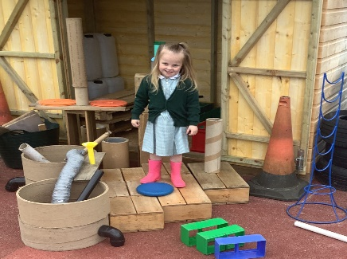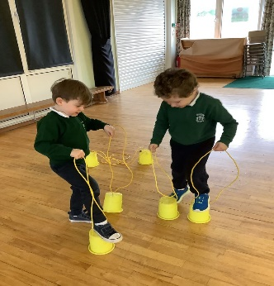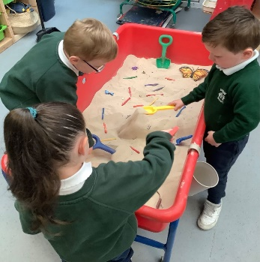

**Positive Behaviour**

Dundela Nursery School encourages positive behaviour reinforcement at all times. This strategy aims to focus on ‘good’ behaviour instead of dwelling on the negative. Children will be rewarded for displaying positive behaviour.

We have a set of statements or “Golden Rules” which the children will be introduced to when they start nursery. It is important that you share and reinforce these at home to avoid confusion.

Our Golden Rules

• We share

• We take turns

• We listen

• We walk

• We tidy up

We explain to the children that rules are made so that everyone can Be Happy in school.

1. Be Kind
2. Be Safe
3. 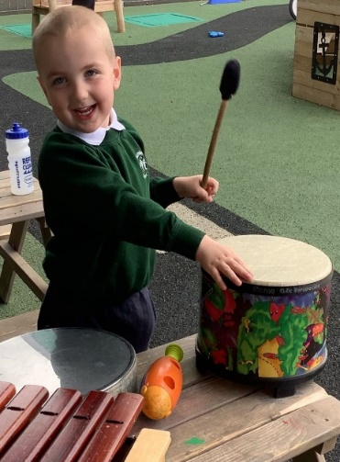Be Ready to Learn

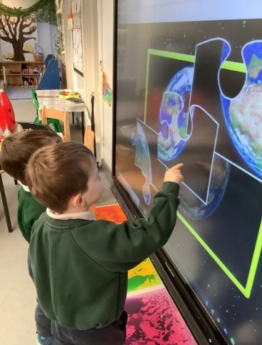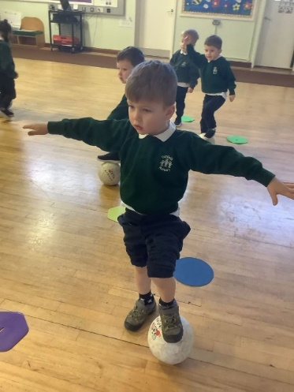

A child may not realise that certain behaviours are unacceptable in nursery as they may be acceptable in other situations, e.g. we can run outside but it is unsafe to run in the classroom. We take time throughout the day to explain to the children why we need the golden rules.

We also point out indoor and outdoor rules and rules of the bathroom e.g. bathroom rules include that we flush the toilet and wash our hands afterwards.

It is our policy that children, who display disruptive behaviour, will be channelled and directed into more constructive, challenging and meaningful play.

The staff will consult parents in the event of any particularly serious problems arising with a specific child.

The full Positive Behaviour Policy is available on request.

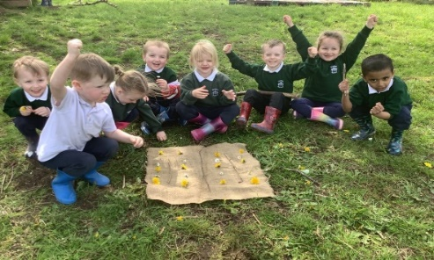

**Parents Comments**

We have been so pleased with every part of Dundela Nursery Unit. We couldn’t recommend it enough. Our son has really became the best version of himself because of his time in Nursery. Both outdoor and indoor facilities are fantastic for the children to learn and explore. The staff are all individually incredible and will treat your child with the utmost respect and care. Thank you for everything you have done for our son in his first year of his school life.

R Lynch

All 4 of my children have attended Dundela Nursery and they absolutely loved it. The support we have received over the years with regards to our children's ASD has been outstanding! The staff are 1st class, you really couldn't ask for more.

S Armstrong

Dundela is a brilliant nursery. My little boy absolutely loves it and has thrived this year. I would definitely recommend the school to anyone!

S Scott